Network Security

Part 1: Introduction to Network Security Technologies

1. What Is Network Security?
Network security refers to the set of technologies and practices designed to protect the integrity, confidentiality, and availability of computer networks and the data they carry. It involves monitoring, controlling, preventing, and responding to unauthorized access, misuse, or malicious activity in a networked environment.

2. Goals of Network Defense
Network defense aims to:
- Protect resources (servers, databases, endpoints)
- Prevent data breaches and unauthorized access
- Detect and respond to attacks in real-time
- Maintain service availability
- Ensure policy compliance

3. Key Principles in Network Security Technologies
Principle | Description
Defense in Depth | Use of multiple layers of security controls to provide redundancy
Least Privilege | Only allow users/devices the minimum access needed
Zero Trust | Never trust, always verify — even internal users
Segmentation | Isolating parts of the network to contain threats
Monitoring | Continuously observing network behavior and detecting anomalies

4. Detection vs Prevention vs Response
Function | Description | Examples
Detection | Identifying malicious behavior or policy violations | IDS, SIEM
Prevention | Blocking malicious traffic or activity before it causes harm | Firewalls, IPS
Response | Acting after detection (e.g., alerting, isolating infected host) | Incident Response System, EDR
This separation helps security teams allocate tools effectively and apply appropriate controls at different layers.

5. Passive vs Active Defense
- Passive Defense:
  - Monitors traffic but does not take direct action
  - Examples: IDS, SIEM, logging systems
  - Useful for forensic analysis and auditing
- Active Defense:
  - Interacts with traffic to block or disrupt attacks
  - Examples: IPS, firewalls, endpoint protection
  - Prevents real-time exploitation

6. Types of Network Security Technologies (Overview)
Technology | Purpose | Passive or Active
Firewall | Blocks or allows traffic based on rules | Active
IDS | Detects suspicious activity | Passive
IPS | Detects and blocks attacks | Active
Honeypot | Lures attackers into fake environments | Passive
This sets the foundation for the detailed study in the next parts of the session.

7. The Defense-in-Depth Model (Layered Security)
A practical approach to building security involves implementing controls at multiple layers of the network. This ensures that if one layer fails, others still offer protection.
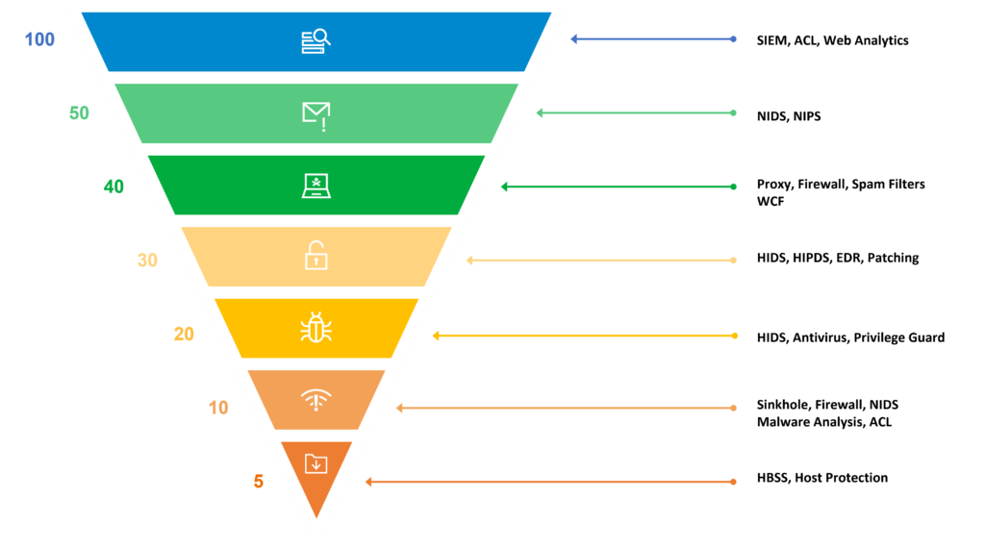
Layers:
- Perimeter Defense – Firewalls, routers, DDoS protection
- Internal Network Security – IDS/IPS, segmentation, VLANs
- Endpoint Protection – Antivirus, EDR (Endpoint Detection and Response)
- Data Security – Encryption, DLP (Data Loss Prevention)
- Access Control – Authentication, MFA, authorization policies
- Monitoring and Response – SIEM, incident response systems

8. Modern Network Security Challenges
- Encrypted traffic: Makes detection harder (e.g., HTTPS hides HTTP methods)
- Cloud and hybrid environments: Expand the attack surface
- Advanced Persistent Threats (APTs): Sophisticated, long-term targeted attacks
- Zero-day vulnerabilities: Exploits unknown to the vendor
- Insider threats: Trusted users causing harm — intentionally or accidentally

9. Where These Technologies Fit
Scenario | Tool to Use
Detect a brute-force SSH attack | IDS (Snort, Suricata)
Block access to malware site | Firewall or IPS
Analyze attacker behavior | Honeypot (Cowrie, Honeyd)
Log all security events | SIEM (e.g., Splunk, Wazuh)
Monitor web traffic in real time | Proxy, NGFW

Part 2: Firewalls – The First Line of Defense

1. What Is a Firewall?
A firewall is a network security device or software that monitors and controls incoming and outgoing network traffic based on predefined rules. It acts as a barrier between a trusted internal network and an untrusted external network (like the internet).

2. Key Functions of Firewalls
- Allow or block traffic based on:
  - IP address
  - Port number
  - Protocol (TCP/UDP)
  - Application type
- Enforce security policies
- Prevent unauthorized access
- Log and monitor connections

3. Types of Firewalls
Type | Description
Packet Filtering Firewall | Filters traffic at the network layer (L3) by IP, port, protocol
Stateful Inspection Firewall | Tracks connection state and context
Application Layer Firewall | Analyzes protocols like HTTP/FTP for deeper filtering
Next-Gen Firewall (NGFW) | Combines firewall + IPS + application control + deep packet inspection
Host-Based Firewall | Installed on endpoints (e.g., Windows Firewall, ufw)
Network-Based Firewall | Deployed at gateways or perimeters (e.g., Cisco ASA, pfSense)

4. Packet Flow Example
Let’s assume a user from inside the network tries to visit http://example.com:
- The user sends a request → firewall checks:
  - Is port 80 allowed?
  - Is destination IP allowed?
  - Is protocol allowed?
- If allowed → passes traffic to the internet
- If denied → packet is dropped, optionally logged
This illustrates stateless or stateful filtering.

5. Basic Rules and Policy Logic
Firewall rules often follow this format:
ACTION PROTOCOL SRC IP SRC PORT DST IP DST PORT
ALLOW TCP 192.168.1.5 any 8.8.8.8 80
DENY ALL any any 10.10.10.1 any
Rules are typically processed top to bottom, and the first match wins.

6. Real-World Firewalls
- pfSense: Free and open-source firewall/router software
- iptables / ufw: Linux-based command-line firewall tools
- Cisco ASA / FortiGate / Palo Alto: Enterprise-grade appliances
- Windows Defender Firewall: Default on Windows
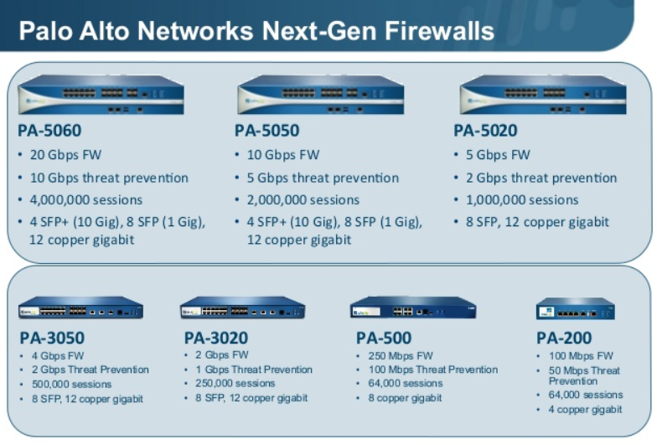

8. Simulated Lab Using iptables (Linux)
Run this on a VM or TryHackMe AttackBox
# Allow only SSH and HTTP
sudo iptables -P INPUT DROP
sudo iptables -A INPUT -p tcp --dport 22 -j ACCEPT
sudo iptables -A INPUT -p tcp --dport 80 -j ACCEPT

# View the rules
sudo iptables -L -v

# Try to ping from another host – should be blocked
ping <VM_IP>

# Try to SSH or browse HTTP – should work
Students will observe:
- Allowed vs denied traffic
- Real-time effect of firewall rule changes
- Logs in /var/log/syslog (depending on distro)

9. Visual Exercise: Designing a Firewall Policy
Ask students to create a sample security policy for a company:
- Web server on port 80
- SSH access only from admin IP
- Block FTP completely
- Allow DNS (port 53) outbound only
Let write rules using simple pseudo-firewall language:
ALLOW TCP FROM admin_ip TO server_ip PORT 22
ALLOW TCP FROM any TO server_ip PORT 80
DENY ALL FROM any TO server_ip PORT 21
ALLOW UDP FROM internal_network TO any PORT 53

Intrusion Detection Systems (IDS)

Part 3: Intrusion Detection Systems (IDS)

1. What Is an IDS?
An Intrusion Detection System (IDS) is a passive monitoring tool used to detect unauthorized access, misuse, or policy violations in a network or host system.
It does not block traffic but analyzes and alerts based on suspicious behavior or known attack signatures.

2. IDS vs Firewall and IPS
Tool | Function | Passive or Active
Firewall | Blocks traffic based on rules | Active
IDS | Detects & alerts on malicious behavior | Passive
IPS | Detects and blocks malicious traffic | Active

3. Types of IDS
Type | Description | Example Tools
NIDS (Network IDS) | Monitors entire network segments for suspicious traffic | Snort, Suricata
HIDS (Host IDS) | Runs on a single host to monitor OS and files | OSSEC, Wazuh

4. Detection Methods
Method | Description
Signature-Based | Uses known attack patterns (like antivirus) — effective for known threats
Anomaly-Based | Uses statistical baselines or machine learning — useful for detecting new/unknown attacks

Signature-Based Example:
- Detects nmap scan pattern or known Metasploit payload.
Anomaly-Based Example:
- Alerts if user suddenly uploads 10 GB of data at 3AM (unusual behavior).

5. Common IDS Use Cases
- Detecting port scanning and reconnaissance
- Spotting brute-force login attempts
- Detecting suspicious DNS or HTTP requests
- Identifying data exfiltration attempts

6. IDS Architecture
A typical IDS has:
- Sensor/Engine – Captures traffic from the network
- Analysis Module – Applies detection logic (signatures or ML)
- Alerting System – Sends logs or messages when something is detected
- Log Storage or SIEM – Stores data for review and response

7. Real-World IDS Tools
Tool | Type | Notes
Snort | NIDS | Lightweight, open-source, rule-based
Suricata | NIDS | Multi-threaded, supports IDS/IPS/NSM
OSSEC | HIDS | Agent-based, monitors system logs/files
Wazuh | HIDS | OSSEC fork, integrates with Elastic Stack

8. TryHackMe Lab (Hands-On Practice)
Recommended Lab: TryHackMe – Detection and Response (Free)
What Students Will Do:
- Analyze logs to detect a brute-force attack
- Review alert messages generated by IDS
- Understand rule matching and signature-based detection

9. Manual Simulation Using Snort
Run this on a Kali or Ubuntu VM with Snort installed.
Step 1: Install Snort
sudo apt update && sudo apt install snort
Step 2: Create a Simple Detection Rule
Create a file called local.rules:
alert icmp any any -> any any (msg:"ICMP Ping Detected"; sid:1000001;)
Step 3: Run Snort with Custom Rule
sudo snort -A console -q -c /etc/snort/snort.conf -i eth0
Then from another system, ping the VM:
ping <snort_VM_ip>
Result: Snort detects and prints the alert in real time.

10. Writing IDS Rules (Snort Example)
alert tcp any any -> any 80 (msg:"HTTP Traffic Detected"; sid:1000002;)
Rule Format:
action protocol src_ip src_port -> dst_ip dst_port (options)
Options include:
- msg = alert message
- sid = signature ID
- content = match string (e.g., "login")

11. Visual: IDS in Action
flowchart like:
[User] → [Switch] → [IDS Sensor] → [Firewall] → [Internet]
↓
[Alert System]

13. Key Takeaways
- IDS detects but doesn’t block — it provides visibility.
- NIDS watches network traffic, HIDS watches host activity.
- Signature-based is accurate but limited to known attacks.
- Anomaly-based can detect unknown threats but may have false positives.
- Snort and Suricata are powerful, free IDS tools used in real-world networks.

Part 4: Intrusion Prevention Systems (IPS)

1. What Is an IPS?
An Intrusion Prevention System (IPS) is a proactive security tool that not only detects malicious activity like an IDS, but also blocks or mitigates that activity in real time.

2. IDS vs IPS – Key Difference
Feature | IDS | IPS
Action | Detects and alerts | Detects and blocks
Placement | Typically passive (monitoring only) | Active, placed inline
Purpose | Visibility, forensic review | Protection, prevention
Reaction Time | Manual or delayed | Automatic, real-time

3. How Does IPS Work?
- Placed inline with traffic (between client and server)
- Inspects packets using:
  - Signature-based detection
  - Anomaly-based detection
  - Policy-based detection
- Blocks or drops malicious packets
- May also reset connections, throttle traffic, or trigger alerts

4. Real-World Use Cases
- Blocking brute-force SSH/FTP attacks
- Preventing SQL injection attacks
- Stopping known malware payloads (e.g., EternalBlue)
- Blocking known attacker IPs (blacklist)
- Preventing command & control beaconing

5. Deployment Modes
Mode | Description
Inline Mode | IPS is part of the traffic path and can drop/block traffic
Passive Mode | Like IDS — just watches and alerts
TAP/SPAN Mode | Traffic is mirrored for analysis, not blocked
Inline mode = actual prevention, not just detection.

6. IPS Tools and Technologies
Tool | Notes
Snort (IPS mode) | Can run inline using NFQUEUE on Linux
Suricata | Supports IDS and IPS out-of-the-box
Cisco Firepower | Enterprise-grade firewall + IPS
pfSense + Snort | Free inline IPS combo using pfSense UI

7. Common Challenges with IPS
- False Positives: Legitimate traffic wrongly blocked
- False Negatives: Malicious traffic missed
- Performance Impact: Real-time inspection may slow traffic
- Rule Tuning: Needs frequent updates and fine-tuning

9. Simulated IPS with Snort in Inline Mode (on Linux)
This example uses NFQUEUE and iptables to make Snort block traffic.
Step 1: Install Required Packages
sudo apt install snort iptables-persistent
Step 2: Configure Snort to Use NFQUEUE
Edit /etc/snort/snort.conf:
config daq: nfq
config daq_mode: inline
Create a blocking rule:
drop tcp any any -> any 80 (msg:"Blocked HTTP Traffic"; sid:1000003;)
Step 3: Add iptables Rule
sudo iptables -I INPUT -p tcp --dport 80 -j NFQUEUE
Step 4: Run Snort in Inline Mode
sudo snort -Q -c /etc/snort/snort.conf -i eth0
Step 5: Test with Browser
Visit any HTTP site → You should be blocked.

10. Visual: IPS in the Network
A simple diagram (to draw or show):
[Client] → [IPS] → [Web Server]
↓
(Block if malicious)

11. Student Activities
- Compare IDS and IPS behavior using a ping or HTTP request
- Write a Snort rule to block a port (e.g., FTP on 21)
- Test if the traffic gets blocked using telnet or browser
- Discuss the risk of false positives in real environments

12. Key Takeaways
- IPS actively blocks threats instead of just detecting them
- It’s most effective inline, but needs careful tuning
- Tools like Snort and Suricata can function as both IDS and IPS
- IPS should be part of a layered defense strategy

Honeypots & Deception Technologies

1. What Is a Honeypot?
A honeypot is a decoy system or resource designed to attract attackers, log their actions, and help security teams study attack methods. It mimics real systems (e.g., servers, services) but is isolated and monitored.
Purpose:
- Divert attackers away from real assets
- Study tools, techniques, and procedures (TTPs)
- Gather threat intelligence
- Detect internal threats

2. Types of Honeypots
Type | Description
Low-Interaction | Emulates basic responses (e.g., open ports, fake login) — safe, lightweight
High-Interaction | Real OS with real vulnerabilities — more dangerous but more informative
Research Honeypots | Used by academics or researchers to study threats
Production Honeypots | Deployed in real networks to detect attacks on live systems

3. Honeypots vs Other Tools
Feature | Honeypot | IDS/IPS
Real Asset Risk | None (isolated) | Monitors real assets
Interaction Type | Designed to be probed/hacked | Detects attacks on production
Logging Detail | Deep attacker session tracking | Focused on detection alerts
Blocking Action | None (passive) | IPS can block

4. Real-World Honeypot Use Cases
- Detect brute-force SSH attacks
- Capture malware droppers or ransomware behavior
- Analyze botnet traffic
- Catch lateral movement from compromised internal machines
- Detect insider threats probing internal infrastructure

5. Popular Honeypot Tools
Tool | Type | Description
Cowrie | Medium/High Interaction | SSH/Telnet honeypot with fake filesystem
Honeyd | Low Interaction | Can emulate multiple hosts and services
Dionaea | Malware collection honeypot
Kippo (deprecated) | Older SSH honeypot, replaced by Cowrie
T-Pot | Full honeypot platform combining multiple tools with dashboards

6. Technical Demo (TryHackMe or Simulation)
Recommended Lab:
🔗 TryHackMe – Honeypots
What students will do:
- Learn how honeypots work
- Interact with a simulated attacker environment
- Analyze logs and attacker behavior
- Deploy and test basic honeypots

7. Lab Simulation: Cowrie SSH Honeypot (for local VM)
Cowrie is one of the most widely used honeypots and is safe if deployed correctly.
Quick Install (On Ubuntu VM):
sudo apt update
sudo apt install git python3-pip python3-virtualenv libssl-dev libffi-dev build-essential libpython3-dev -y
cd /opt
sudo git clone https://github.com/cowrie/cowrie.git
cd cowrie
sudo useradd -r cowrie
sudo chown -R cowrie:cowrie /opt/cowrie
sudo -u cowrie -H ./bin/install.sh
Start the honeypot:
sudo -u cowrie -H ./bin/cowrie start
Then try SSH into it from another machine:
ssh root@<honeypot_ip> -p 2222
It will record everything you do — commands, timing, etc.
Logs found in:
/opt/cowrie/var/log/cowrie/

8. What to Monitor in Honeypots
- IP addresses of attackers
- Credentials they try (e.g., common usernames/passwords)
- Commands they execute (e.g., wget, curl, nmap)
- Dropped payloads (often malware or crypto miners)
- Exploits they attempt
This helps security teams learn attacker behavior and adapt defenses.

9. Risks and Best Practices
- Never connect honeypot to internal trusted network
- Use firewall rules to limit attacker pivoting
- Monitor outbound connections carefully
- Don’t reuse captured malware on live systems without sandboxing

10. Student Challenge
Give students these tasks:
- Identify the differences between low and high-interaction honeypots
- Test Cowrie on TryHackMe or local VM
- Observe log files and extract:
  - IP address
  - Commands used
  - Attempted credentials
- Discuss what this tells you about the attacker’s goals

11. Key Takeaways
- Honeypots are deception tools used to trap and observe attackers
- They come in different interaction levels
- Tools like Cowrie can capture attacker commands and behavior
- Honeypots help improve threat detection and understanding
- Best deployed in isolated test environments

